Node JS

-JavaScript runtime build on googles open-source V8 JavaScript engine.

* Single-threaded, based on event driven, non-blocking Input/Output model
* Perfect for building fast and scalable data-intensive apps

Use node for:

* API with database behind it (preferably NoSQL)
* Data streaming
* Real-time chat app
* Server-side web app
* JavaScript across the entire stack
* NPM: huge library of open-source packages available free
* Very active dev community

Don’t use node for:

* App with heavy server-side processing

-Da bih pokrenuo Node, dovoljno je u terminalu da upisem ‘node’ I enter. Ako nakon toga kliknem ‘tab’ dobicu sve dostupne globalne variable.

-Da bih izvrsio neki file, kucam ‘node <ime file-a>’.

-Da bih (Sync) procitao neki file iz filesystem-a koristim ‘fs’ module:



-Da bih (Sync) zapisao neki file:



-Synchronous code je ‘blocking’, zato najcesce procese odvijamo u ‘pozadini’ uz pomoc Asynchronous code-a.

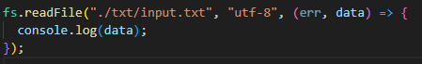

Ili za pisanje:

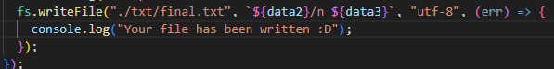

- Pravljenje web servera:

* Kreiranje servera

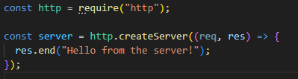

* Slusanje servera

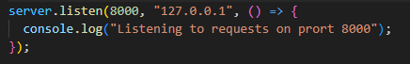

- Routing:

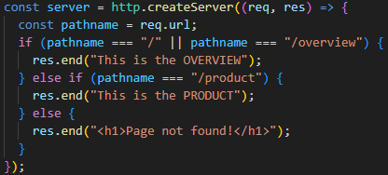

-Headers je informacija koju saljemo nazad o response-u

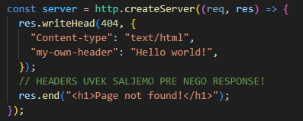

- API je servis od kojeg zahtevamo neku datu

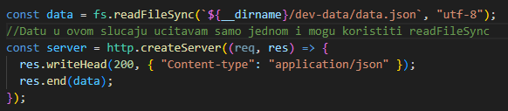

- Parsing variables from URLs



- Kreiranje modula:

* Napravim file (u modules folderu)
* U njemu pisem funkciju 
* Tamo gde zelim da ga koristim 